**CSE103L Circuits & Systems-I Lab**

**Circuits And System 1**

**LAB REPORT # 11 &12**



2020

**Submitted to:**

**Engr. Faiz Ullah**

**Submitted by:**

**TAYYABA**

**Registration No:**

**19PWCSE1854**

**Semester: 2nd**

**Class Section: C**

“On my honour, as student of University of Engineering and Technology, I have neither given nor received unauthorized assistance on this academic work.”

Student Signature: ______________

Friday, July 24, 2020

**Department of Computer Systems Engineering**

**University of Engineering and Technology Peshawar**

**ASSESSMENT RUBRICS LAB # 11 & 12**

**Thevenin’s and Norton’s theorem using PSpice**

|  |  |  |
| --- | --- | --- |
| **Criteria** | **Excellent** | **Marks Obtained** |
| 1. **Objectives of Lab** | All objectives of lab are properly covered  [Marks 0.5] |  |
| 1. **Thevenin and Norton’s Theorem** | Brief introduction to both the theorems and circuit diagrams and mention “ab” terminal points.  [Marks 1.5] |  |
| 1. **PSpice** | Brief introduction and steps for simulation  [Marks 2] |  |
| 1. **Observations and calculations** | Each step to obtain final result along with circuit diagrams  [Marks 5] |  |
| 1. **Conclusion** | Conclusion obtained from readings  [Marks 1] |  |

# Experiment # 11&12

Verification of Thevenin’s and Norton’s Theorem

**Objectives:**

To verify Thevenin’s and Norton’s theorem on simulation tool PSPICE

# Apparatus:

* Computer with PSPICE software installed on it

# Norton & Thevenin Theorem:

Thevenin’s Theorem states that it is possible to simplify any linear circuit, no matter how complex, to an equivalent circuit with just a single voltage source and series resistance connected to a load. Thevenin’s Theorem is especially useful in analyzing power systems and other circuits where one particular resistor in the circuit (called the “**load**” resistor) is subject to change, and re-calculation of the circuit is necessary with each trial value of load resistance, to determine voltage across it and current through it.

In this lab we perform experiment to verify the Norton & Thevenin Theorem. Consider the following circuit for the verification of the theorem:

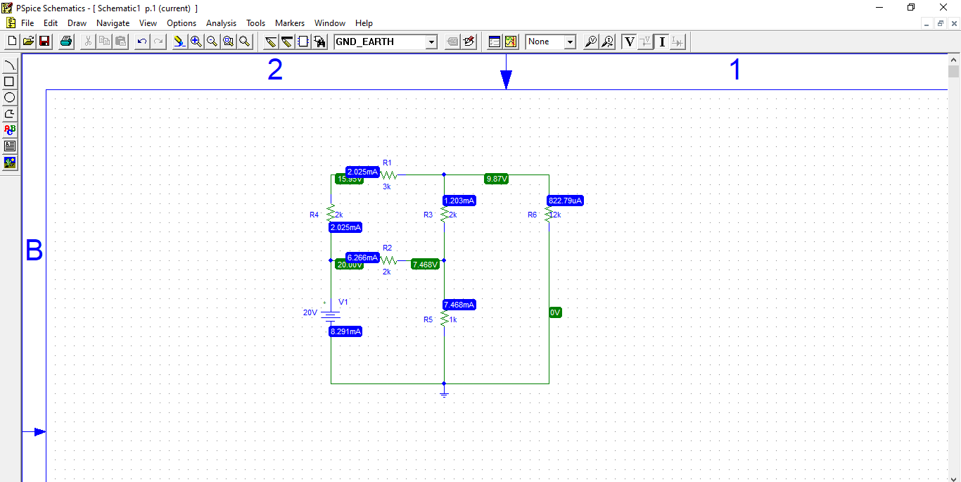

**Figure 1** Circuit Daigram

In Norton & Thevenin Theorem we perform the following three steps:

1. Remove the resistor R5 and leave the circuit open across R5.
2. Remove the resistor R5 and join the wires across R6 to short the circuit.
3. Find $R_{TH}$ which is given as:

$$R_{TH}=\frac{V_{TH}}{i_{SC}}$$

Now we have to perform these steps on our circuit to find ${ R}_{TH}$ (Thevenin Resistance) and $I_{n}$ (Norton current).

**PSPICE Simulator:-**

**PSPICE** is a computer-aided simulation program that enables you to design a circuit and then simulate the design on a computer. As this is one of its main purposes, it is used extensively by electronic design engineers for building a circuit and then testing out how that circuit will simulate. There are a lot of things we can do with **PSPICE**, but the most important things for you to learn are

1. Design and draw circuits.
2. Simulate circuits.
3. Analyze simulation results.

**Procedure:**

1. Open schematic program of PSpice.
2. Click on the “**Get New Part**” button on the toolbar.
3. Type ‘**r**’ in the search bar and place the eight resistors on the white sheet.
4. Type ‘**vdc**’ in the search bar and place it on the white sheet.
5. Type ‘**gnd-earth**’ and place two of them on the white sheet.
6. Now arrange these components on the white sheet according to the circuit diagram as following.

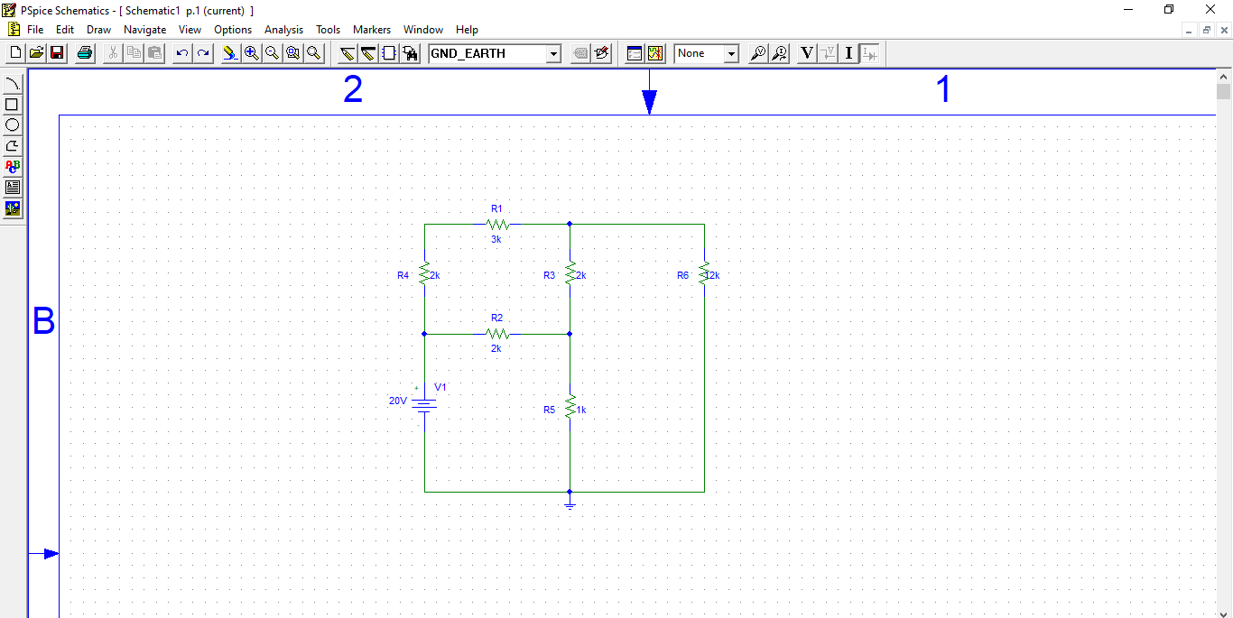

**Figure 2** Arrangement of Circuit

1. After arranging click on **simulate** button and the following results are generated.

**Observation and Calculation:-**

**Finding Thevenin Resistance ($R_{TH}$):**

To find Thevenin Resistance **($R_{TH}$)** we have to first find the $V_{TH}$ and $i_{SC}.$

**Finding $V_{TH}$:**

To find $V_{TH}$ we have to modify our circuit i.e remove the resistor R5 and leave the circuit open across R5:

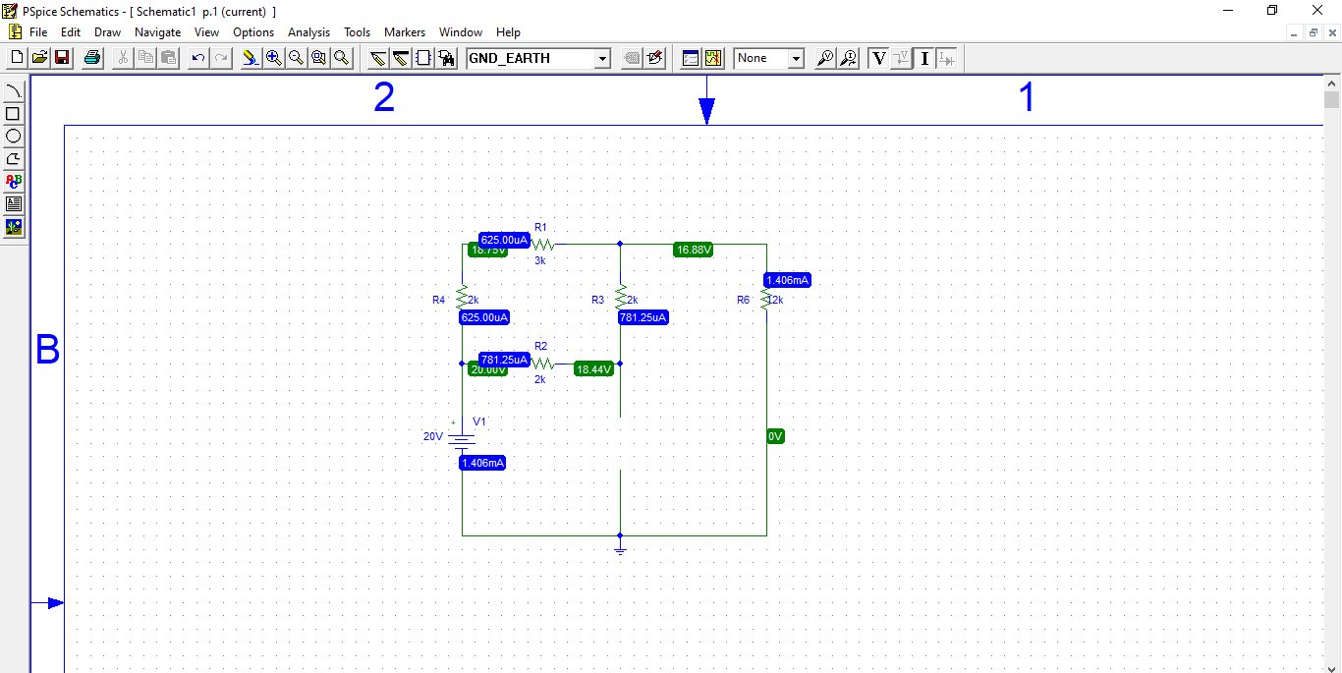

**Figure 3** Modified circuit daigram for **VTH**

Now the voltage across R5 (which is now open) is the required $V_{TH}$ i.e

$$V_{TH}=18.44V$$

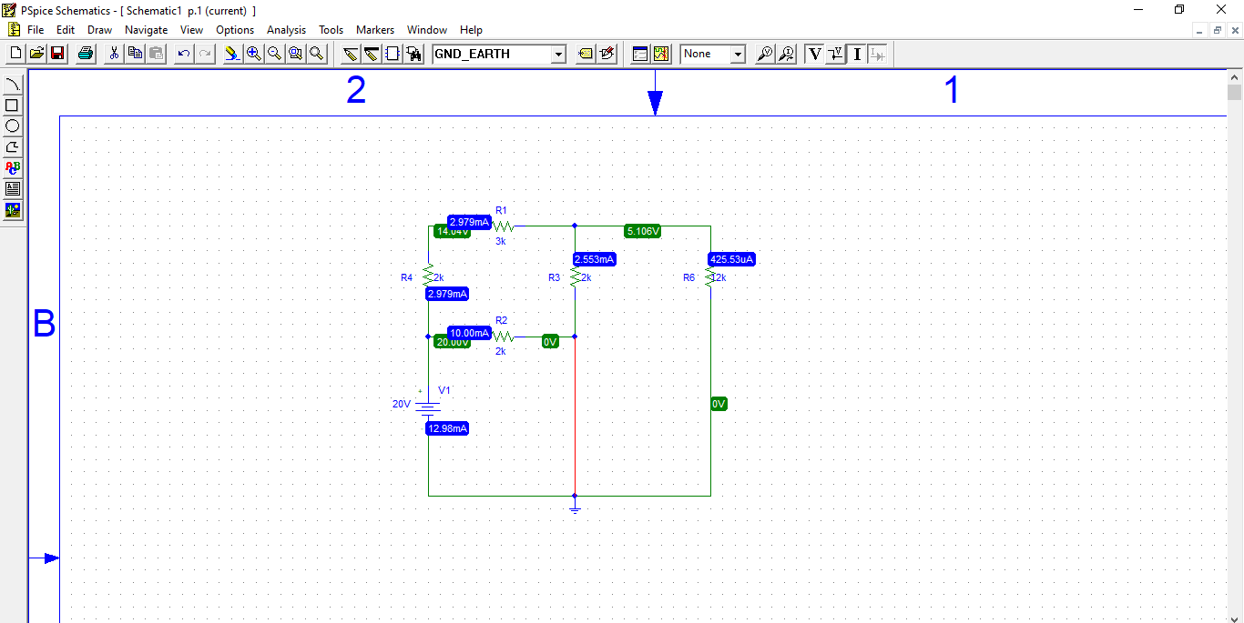**Finding $i_{SC}$:-**

**Figure 4** Modiefied Circuit Daigram for **isc**

To find $i_{SC}$ we have to modify our circuit i.e remove the resistor R5 and join the wires across R5 to short the circuit:

Now the current across R5 (which is now removed) is the required $i_{SC}$ i.e

$$i_{SC}=12.98 mA$$

**Finding Thevenin Resistance (RTH):-**

Now we can find the Thevenin resistance using the give formula:

$$R_{TH}=\frac{V_{TH}}{i_{SC}}$$

$$R_{TH}=\frac{18.44}{0.01298}$$

$$R_{TH}=1421 Ω$$

**Now finding the Norton current ${(I}_{n})$:**

We can find the Norton current ${(I}_{n})$ by using formula:

$$I_{n}=\frac{V_{TH}}{R_{TH}}$$

$$I_{n}=\frac{18.44}{1421}$$

$$I_{n}=0.012976A$$

$$I_{n}=12.98 mA$$

Using these values of Norton current ${(I}_{n})$**,** Thevenin Resistance **($R_{TH}$)** & Thevenin voltage **($V_{TH}$)** we can perform source Transformation and can a simplified circuit that represent the whole big circuit.

# Source Transformation:

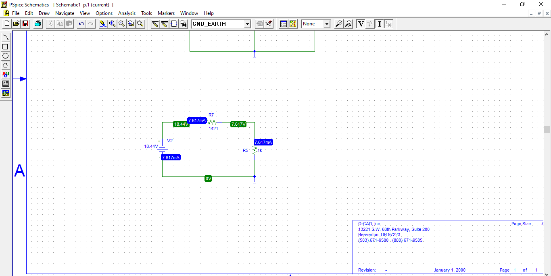

**Figure 5** Source Transmission (Voltage Source)

In the above circuit voltage source has a value of that of $V_{TH}$ and the resistor R7 has value of that of $R_{TH}$. This circuit now represent the whole circuit given in the **Figure 1**.

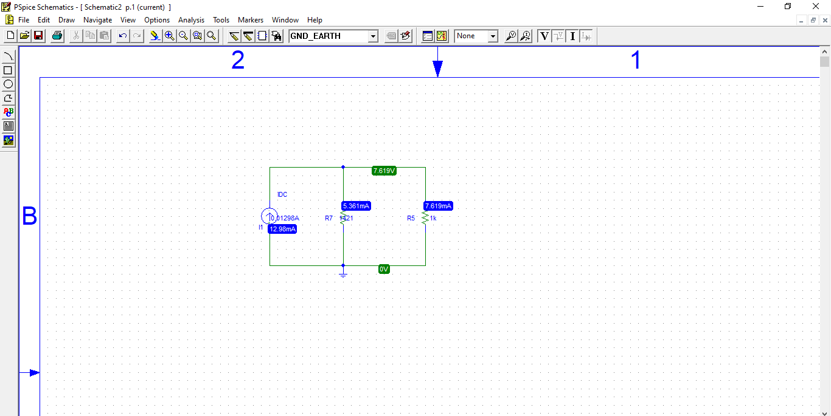

**Figure 6** Source Transmission (Current Source)

In the above circuit current source has a value of that of $I_{n}$ and the resistor R7 has value of that of $R_{TH}$. This circuit now represent the whole circuit given in the **Figure 1**.

**Conclusion:-**

After completely solving circuit using Pspice, we come to know that Thevenin’s and Norton theorem is verified using Pspice simulation tool.